Water Berlin 2006
International DWA Symposium on Water Resources Management
- Water Resources Management in Agriculture

Reduction of diffuse entries from farmland in a catchment in Thuringia (Germany)

Dr. Richard Beisecker, Malsfeld
Dr. Manfred Fink, Dr. Sven Kralisch, Jena
Roland Mauden, Erfurt

Address of authors:
Dr. Richard Beisecker
Ingenieurbüro für Ökologie und Landwirtschaft (IfÖL)
Büro für angewandte Ökologie und Forstplanung (BÖF)
Hafenstr. 28
D-34125 Kassel
rb@ifoel.de

Roland Mauden
Thüringer Fernwasserversorgung (ThürFWV)
Haarbergstr. 37
D-99097 Erfurt
roland.mauden@thueringer-fernwasser.de

Dr. Manfred Fink
Dr. Sven Kralisch
Institut für Geographie - Lehrstuhl für Geoinformatik
der Friedrich-Schiller-Universität Jena
Löbdergraben 32
D-07743 Jena
Manfred.Fink@Uni-Jena.de
Sven.Kralisch@Uni-Jena.de

Introduction
The European Water Framework Directive (WFD) which came into force in December 2000 aims to preserve good chemical and ecological conditions for the European river systems until 2015. Therefore river basin based management plans have to be developed and measures to achieve the objectives are to be undertaken by the authorities.
The results of the inventory of the EU-WFD show, that in Germany achieving the objective of a good status of water bodies until 2015 according to art. 5 WFD was classified as being improbably for 60 % of surface water bodies and 53 % of groundwater bodies. There are two main reasons for failing to meet the objective referring to the surface water bodies. Besides the structural (morphologic) alteration the substantial and organic impact is the most important reason. The impact is traced back to punctual pollution loads from wastewater and direct discharge and especially to diffuse nutrient input following from agricultural land use.
In preparation of the management plans and measure programmes that have to be conducted from 2006 according to the time limit of the WFD, the TMLNU has carried out 9 exemplary projects in order to the river basin management. The project aims to check a collective implementation of the interdisciplinary and complex measures in which various institutions, associations, agencies and users are involved. Furthermore the aim is to optimise the collaboration between all participants and to prove how to involve them in planning and conducting the measures by concrete schemes.
In order to this the Thüringer Fernwasserversorgung (TFW) in Erfurt got the assignment to implement one of these projects. The following report refers to this project.
- Project description
The project for reducing diffuse nitrogen entries from farmland in the Weida catchment (east thuringia) is conducted by the Thüringer Fernwasserversorgung (TFW) by the order of the federal state of Thuringia (TMLNU, Erfurt) and is co-financed by the European Union. Participants of the project are the TFW in Erfurt, the agricultural companies, who cultivate the fields inside the mentioned area, the engineering companies IfÖL and BÖF in Kassel and the expertise centre for dynamic of complex geological systems (Kompetenzzentrum Dynamik komplexer Geosysteme (DKS)) of the Friedrich-Schiller-University in Jena. The project started in the autumn of 2004 and proceeds until the end of 2006.
The project consists of three general strategies to reduce the nitrogen pollution of rivers and an additional decision support system. The first strategy promotes the extensification or even the set-aside of grassland that goes along with the streams. The aim of this strategy is to establish a buffer soil system with very low nutrient content between the surface waters and the intensely used agricultural land. The second strategy focuses on the fertilisation practise of the farmers and the possibilities to optimise the fertiliser utilisation of the crops. On the one hand this includes the promotion of special fertilisers and additives which inhibit the nitrification from immobile ammonium to nitrate which is soluble and therefore mobile in the soil water. On the other hand it includes an intense advisory service for the local farmers to optimise the use of nitrogen referring to the plant’s developmental stage and the calculation of nitrogen release from manure. The third strategy is designed to store the nitrogen surplus after the harvest and to immobilise the nitrate following up the mineralization in autumn. The measure for achieving this aim is the cultivation of catch crops.
The different fields where these measures are likely to perform with good success can be identified by a decision support system (Integriertes Wasserwirtschaftliches Enscheidungsunterstützungs- System (IWES)) which is developed on the base of water and nitrate transport models for soil water. The system will be able to identify areas where certain measures to reduce the nitrate discharge are particularly effective compared to other sites.
The result checking includes two levels. The first one is to control the proper realisation of the measures stipulated with the farmers and soil analysis of nitrate content after harvest and before and after winter. The water quality and quantity monitoring at Weida River at gauge Läwitz near Zeulenroda reservoir is the second method to control the success of the measures especially referring to water quality improvement and nitrogen load. This is possible due to the water monitoring infrastructure of the two drinking water reservoirs which are situated within the project area.
The project provides expertise and tools to develop well organised management plans and to apply suitable and successful predefined measures for drainage areas, where the agricultural land use leads to similar impacts on surface and ground waters as in the Weida drainage area. The results allow calculating the costs of measures and estimating the applicability of the possible measures in order to achieve the objective to reduce the local diffuse nitrate load.

Project area and land use
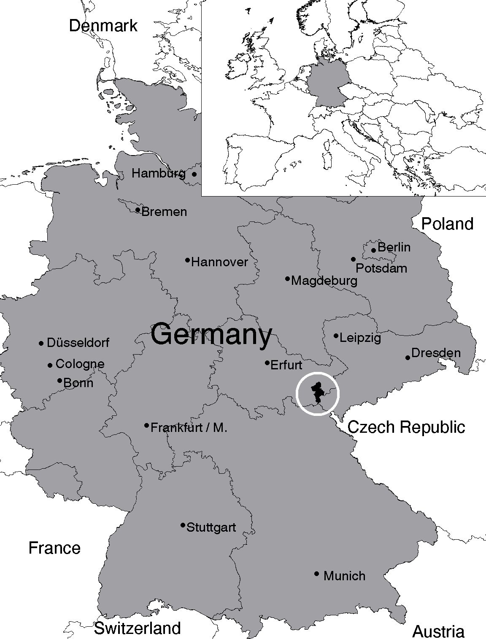
The catchment of Weida River is situated in Vogtland, at the frontier between the two federal states of Saxony and Thuringia in Germany. The project area is a part of the Thuringian catchment of the Zeulenroda and Weida reservoirs, which are located in the Thuringian Slate Mountains and cover an area of about 118.8 km² (Figure 1). The streams of the area flow into Weida River which is dammed twice and forms two consecutive drinking water reservoirs in the area. The first one is the Zeulenroda reservoir which has got a storage capacity of about 30.4 million cubic metres followed downstream by the Weida reservoir with a gross capacity of 9.7 million cubic metres. The system provides an annual drinking water amount of about 12 million cubic metres for more than 300 000 people. The reservoirs drain via the river Weida into the river Weisse Elster, which is part of the Elbe catchment.
The altitude in the project area varies between 315 and 565 m above sea level. Located in the rain-shadow of the Thuringian Forest Mountains, the annual average precipitation is only approximately 690 mm. This portion is divided in approx. 210 mm runoff and 480 mm evapotranspiration annually. The annual average temperature is also low at approx. 7° C. The geology is dominated by clay schists and eruptive rocks. Most of these rocks have a low permeability. This causes interflow to be the dominant runoff process in the region. The soils developed from this bedrock range from shallow rankers to well developed cambisols and fluvisols in the river valleys.
Figure 1: The location of Weida catchment [2]
Main waters in the Weida catchment which is predominantly used agriculturally are the rivers Weida and Gülde. These rivers count to the most nitrate fraught waters in thuringia.
Nearly two thirds of the project area is intensely used agricultural land. Arable land covers about 72.4 km² (61 %) and forestry approx. 33 km² (27.8 %). Residential and traffic areas have a portion of 6.7 % and water areas cover about 3.6 % of the project area (figure 2).
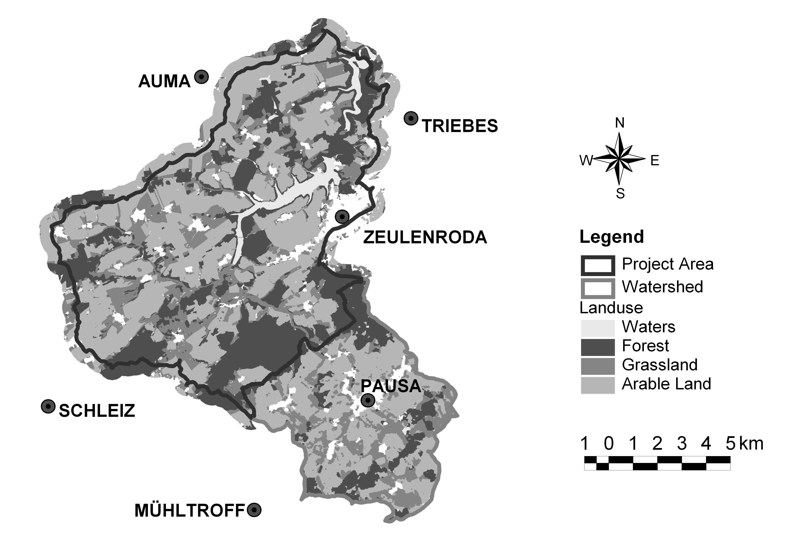
Figure 2: Thematic map representing different land use categories in the
catchment area of Weida reservoir

Water Balance and Nitrate Load
The mean annual precipitation in the region varies between 620 mm•a⁻¹ and 690 mm•a⁻¹. This causes the Weida river discharge amounts of about 33 million cubic metres a year at the outlet of Weida reservoir. Considerable discharge events usually occur in winter from November until April. During this station the runoff reaches 85 % to 95 % of the entire annual runoff.
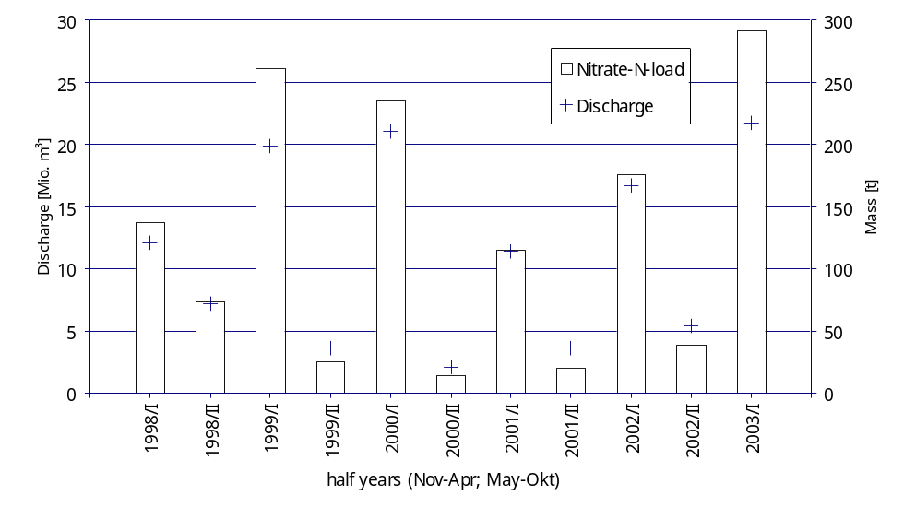
Figure 3: Discharge and nitrate load at Läwitz gauge apportioned into
summer and winter periods from 1998 to winter 2003
Data with a high temporal resolution are available from a gauge at Läwitz at the entrance of Weida River into Zeulenroda reservoir. There the water quality and quantity is monitored and recorded each 15 minutes since 1998. A special nitrate sample provides data to determine exact loads at this point of the river. The data from this gauge is used to monitor the over-all success of the measures concerning the change of nutrient transport into the surface water (Table 1).
Besides the little discharge of nitrate from forested areas (approx. 20 t•a⁻¹) there are two major sources of nitrate in the surface waters of Weida drainage area. These are the municipal waste waters from different towns and villages which provide about 50 t•a⁻¹ and the diffuse nitrate discharge from agricultural land use. The nitrate load from farmland reaches from 134 t•a⁻¹ (2001) to 340 t•a⁻¹ (2003). The mean nitrate load at Läwitz gauge has been 240 t•a⁻¹ since 1998. This leads to a mean nitrate discharge from agricultural land of about 38 kg•(ha•a)⁻¹ in the project area.
To keep nitrate concentrations below 50 mg•l⁻¹ for most time of the year, the mean value should be clearly below 45 mg•l⁻¹ (weighted mean by discharge volume). In the case of Weida drainage area the objective is to reduce the mean nitrate release from agricultural used land to less than 32 kg•(ha•a)⁻¹.
Hydrological Year (Nov-Oct) | 1998 | 1999 | 2000 | 2001 | 2002 | 2003 (Nov-Apr)
Discharge Q [10⁶ m³] | 19,22 | 23,43 | 23,11 | 15,00 | 22,10 | 21,74
Nitrogen load [t] | 211 | 286 | 248 | 134 | 214 | 291
Mean Nitrate Content [mg•l⁻¹] | 48,5 | 54,0 | 47,6 | 39,6 | 42,9 | 59,2
Nitrogen release [kg•ha⁻¹] | 20,5 | 27,7 | 24,5 | 13,2 | 21,1 | 28,6
Specific yield [l•s⁻¹•km⁻²] | 5,92 | 7,21 | 7,11 | 4,62 | 6,80 | 6,69
Table 1: Summarised discharge and nitrogen load data of the Läwitz gauge at Weida River

Identification of sensitive fields with the IWES system
In order to find the most sensitive fields for the measures in these project, an integrated decision support system (IWES) is used. IWES is supposed to support catchment managers and should ensure, that only land use scenarios characterised by the following properties are generated:
- Reduction of the nitrogen concentration in the reservoir in order to observe the legal boundary values for nitrogen concentrations and to reduce the expenditures for the management of the water body of the reservoir.
- Minimization of the cost for the measures
Due to the enormous range of parameters which must be considered this is a very difficult problem whose exact solution is intractable in practice. We therefore developed an optimization procedure that finds very good approximations to the exact solutions.
The hydrological Model
An optimization procedure of the mentioned kind cannot be built without knowledge about the relationship between the field-specific land use on the one hand and the nitrogen concentration in the reservoir on the other. For the computation of this relationship the water and nitrogen modelling tool WASMOD (Water and Substance Simulation Model) [3] is used. Since the measures for nitrogen reduction are applied to single agricultural fields the model must not only operate on the catchment scale but also on the plot level. WASMOD can do both of this simultaneously. It allows describing the nitrogen discharge as a function of soil, relief, land use and climate.
An application of WASMOD presumes that GIS-layers of soil, relief, land use, river network, sub catchments and relief units (slopes, sinks and plains) are assembled to smallest common geometries (SCGs). These SCGs result from a polygon overlay union analysis of the GIS-layers mentioned above. For WASMOD the SCGs are not further classified into hydrological response units (HRUs, c.f. [4]) which allow explicit modelling of interaction processes on the SCG level.
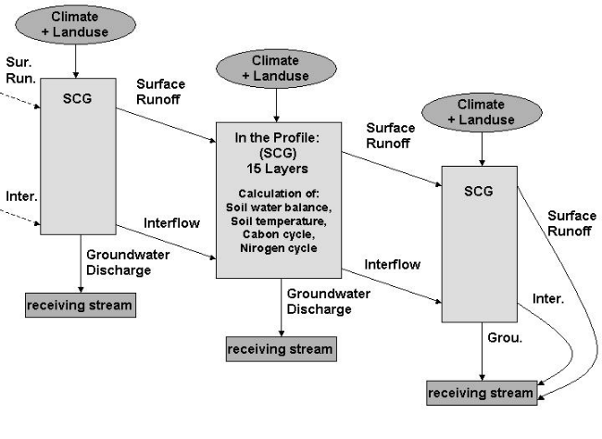
A simplified routing scheme representing the water and substance fluxes in the catchment is shown in Figure 3. The model calculates the water and substance balances in each of the SCGs and routes the fluxes to the next downstream polygon where the calculation starts again. This process ends at the receiving stream where all fluxes are added up. The sum represents the model output for the whole catchment. Since WASMOD is able to model physical processes directly it is especially suited for the simulation and evaluation of land use and climatic scenarios.
Figure 3: Model routing scheme of WASMOD [2]

In Figure 4 the simulated and observed nitrogen load for the years 1990 - 2000 at a yearly time step is shown. The coefficient of determination (R²) for our calculation amounts to 0.89 and the mean annual derivation is 11.8 %. The dry years at the beginning of the shown period shows too high values in the simulation. The reason for this is a water simulation that has to high values too, caused by to much inertia in the groundwater simulation (Fink 2004).
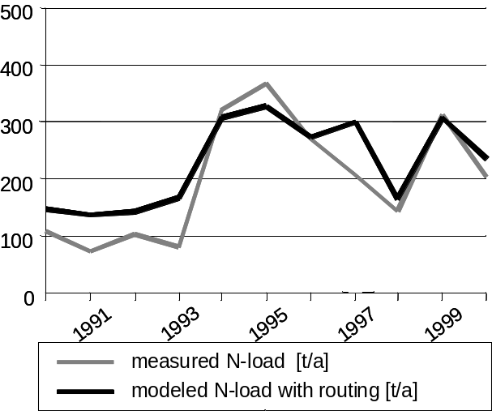
Optimization procedure
Our optimization procedure uses neural networks to do its job. Neural networks consist of simple autonomous processing units (neurons) which are joined by directed communication paths (edges). Each edge is parameterized with a numeric value (weight) which specifies the strength of the connection between the connected neurons and thus the ability to pass signals. A so-called activation function is assigned to each neuron enabling it to calculate an output signal dependent on signals received over incoming edges. This output is then propagated to the neighbouring neurons. A neural net can therefore be seen as a machine which computes a function that is characterized by a possibly large set of parameters (represented by the weights). There are learning algorithms that can fine tune the parameters of a given neural net such that the function computed by this net approximates a given function as good as possible. Neural nets are therefore especially suited to solve hard optimization problems.
Figure 4: Simulated and observed yearly nitrogen load in t of the gauge Läwitz.
The network we used for this project (HYDRONET) works similar (Kralisch 2004). First we generate a network with the same topology as the relief depending model units (SCGs) of WASMOD (Figure 5, left). Every SCG is represented by one neuron. This neuron can calculate the nitrogen output depending on the nitrogen input individually with its activation function.
For the determination of the activation function WASMOD was used. Therefore we calculated 13 five year scenarios with different nitrogen input. The range of the nitrogen input variation was chosen to include every meaningful fertilisation. After the calculation of the scenarios with WASMOD we get a relation between the input of the different scenarios and the corresponding output for every SCG, which is used as activation function for the neurons.
The edges between the neurons represent the strength of the nitrogen fluxes in the WASMOD model (Figure 5, right). There are additional edges which represent the nitrogen input by fertilisation and atmospheric deposition.
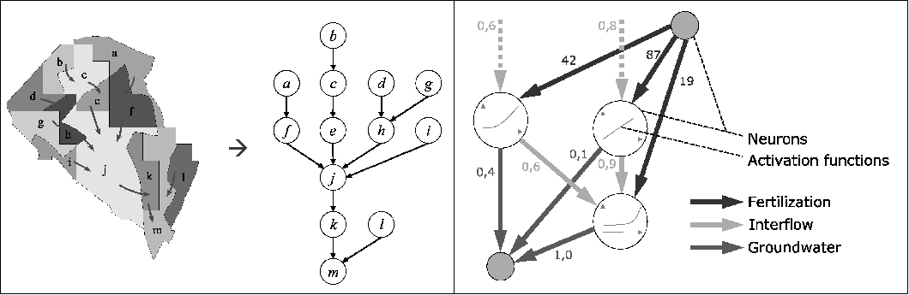
Figure 5: Subcatchment with SCGs and lateral flow paths and corresponding HYDRONET with interflow edges (left). Edges and activation functions of a HYDRONET [5]
The real fertilisation of the field represented by the input edges can be modified with an adapted learning procedure, that way that the output not exceeds a chosen value at the catchment outlet (reservoir). Therefore the optimisation procedure can be seen as an invertation of WASMOD. The procedure is able to modify the fertiliser input on that fields that have the highest sensitivity for the water quality in the reservoir. Another property of the learning procedure is that the sum of fertilisation changes necessary to create a desired output is minimal. That means that the costs to establish the measures for nitrogen reduction are also minimal.
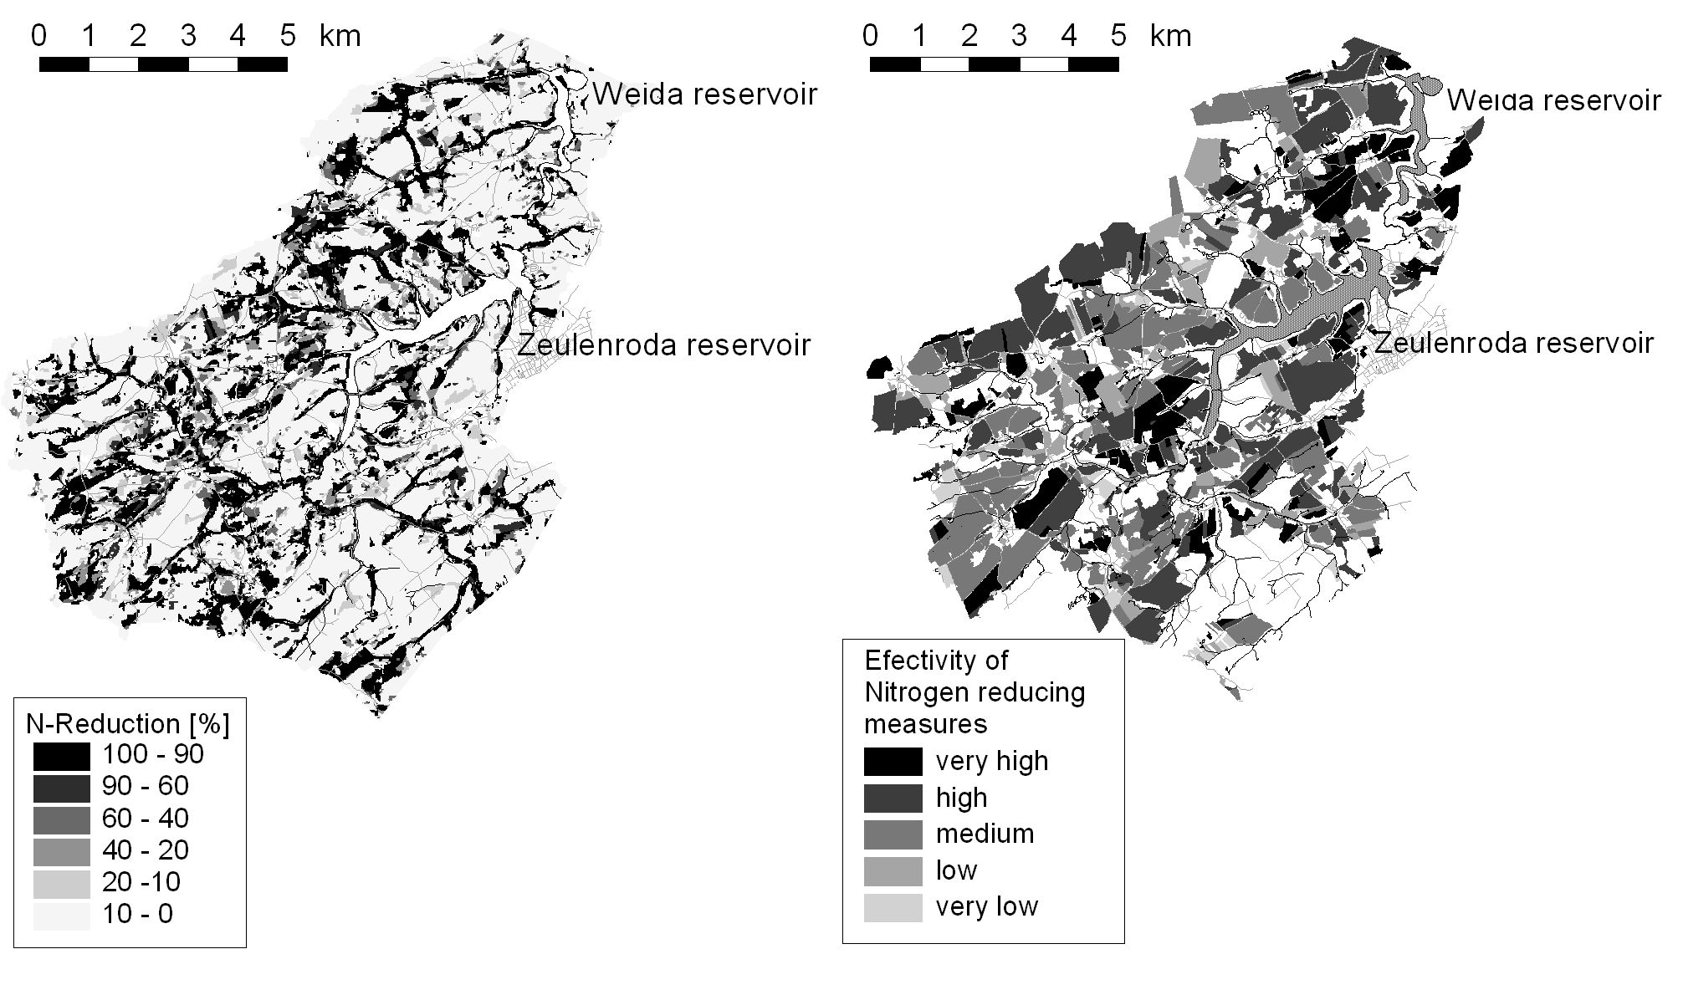
Figure 6: Results of the learning procedure of HYDRONET, on SCG-level (left) and on
agricultural field level (right).
In order to validate the fertilization changes calculated the HYDRONET we used the results to set up WASMOD again. After modelling the catchment with the modified fertilization inputs the change in the output is 23 % reduction. The predicted reduction with the HYDRONET was 25 % which is a rather good fit to the WASMOD results [5].
In figure 6 the aerial results of learning procedure of HYDRONET is shown. On the left map the fertilisation reduction on SCG-level is shown. A high value means that the sensitivity of this model unit is high and measures for nitrogen reduction are very effective. For planning purposes we generalised this result to the agricultural fields shown in the right map of figure 6. This map was an important basis for the distribution of the nitrogen reducing measures.

Implementation of measures
According to the strategies described introductorily to reduce nitrate discharge into the reservoir system there are implemented three measures of main focus so far.

Grassland extensification (strategy 1)
The results of the IWES-model calculations identify especially the grassland areas in the riverside as particularly sensitive for effective nitrogen reducing measures as well as the hilltop sites with thin soil cover where the risk of nitrogen discharge is high. This is mainly caused by the high part of interflow on the entire run-off. In the (course)?? case of interflow, the seepage water fraught with nitrate flows from the bordering arable land downwards into surface waters.
Therefore we worked out an extensification concept for the grassland areas in the riverside of the rivers Weida and Gülde. It includes the following measures:
- Fenced off areas with at least 5 m distance to the surface water that must not be grazed
- First and partly second use by cutting to realize a drain of nutrients as high as possible
- Limited nitrogen fertilizer application until an total nitrogen amount of 60 kg (organic and mineral)
- Obligatory measures for caring the turf after every use

An entire area of approximately 100 ha grassland was stipulated for these extensifications. The farmers are getting fixed compensation balances for implementing the measures mentioned above. To control the proper realisation the measures were monitored in spring and autumn.

Optimized nitrogen fertilizer application (strategy 2)
To improve the crop nitrogen utilisation especially with manure the application of additives which inhibit the nitrification is promoted monetary within the project. The nitrification inhibitors retard the microbiological conversion from ammonium-nitrogen to nitrite carried out by nitrosomonas. Afterwards the nitrate will be converted into nitrate by nitrobacter. Thereby the nitrogen which is due to manure or crop residues which can be simply mineralised is balanced in immobile ammonia-nitrogen for a period of 4-10 weeks. The length of this period depends on certain factors like temperature, soil texture, moisture and others. In spite of nitrate ammonium is a cation and can be fixed by the soil sorption complex and therefore is being protected from a fast shift with the seepage water.
By adding a predetermined amount of nitrification inhibitor especially to slurry, the hibernal nitrate discharge should be diminished and the period of the effect of nitrogen fertilizers should also be extended. The surplus costs at the expense of the participating farmers due to the application of nitrification inhibitors are compensated until now. The extension of area where application of nitrification inhibitors is promoted is shown in table 2.
Year | Periode | Area [ha]
2004 | autumn | 425
2005 | spring | 605
2005 | autumn | 426
Table 2: Area with application of N-stabilized fertilizer

Reduce of Nitrogen surplus (strategy 3)
The nitrogen surplus existing on the arable land after the harvest is at risk of being leached during the hibernal seepage water period. In order to prevent this, the cultivation of catch crops is promoted. The participating agricultural companies get a refund for the surplus costs for the cultivation of catch crops. The proper realisation of this measure is controlled by a field-monitoring at the end of growing season.
Because of site conditions and the objective of this measure the cultivation of only some certain catch crop cultures have the admission of being promoted. For example the drilling of legumes in the catchment is prohibited because of providing additional nitrogen.

First results
Sowohl zur Erfolgskontrolle der umgesetzten Maßnahmen als auch dem Stickstoff-Monitoring im Einzugsgebiet werden regelmäßig im Frühjahr und im Herbst Nmin-Beprobungen durchgeführt. Dazu werden von einem Schlag repräsentative Proben aus den obersten beiden Bodenschichten (depth 0-30 cm and 30-60 cm) gezogen und auf den Nitrat- und Ammoniumgehalt analysiert. Die Ergebnisse werden statistisch und flächenbezogen ausgewertet und in die weitere Maßnahmenplanung einbezogen. Als Zielwert für eine gewässerverträgliche Bewirtschaftung wurde ein Rest-Nmin-Gehalt von ≤ 50 kg N/ha vereinbart.
In Abbildung 7 sind beispielhaft die schlagbezogenen Nmin-Ergebnisse der Nachernte-Beprobung 2005 (n ≈ 400) dargestellt. Die flächenhafte Verteilung lässt verschiedene Bereiche mit besonders hohen Rest-Nmin-Gehalten nach der Ernte erkennen.
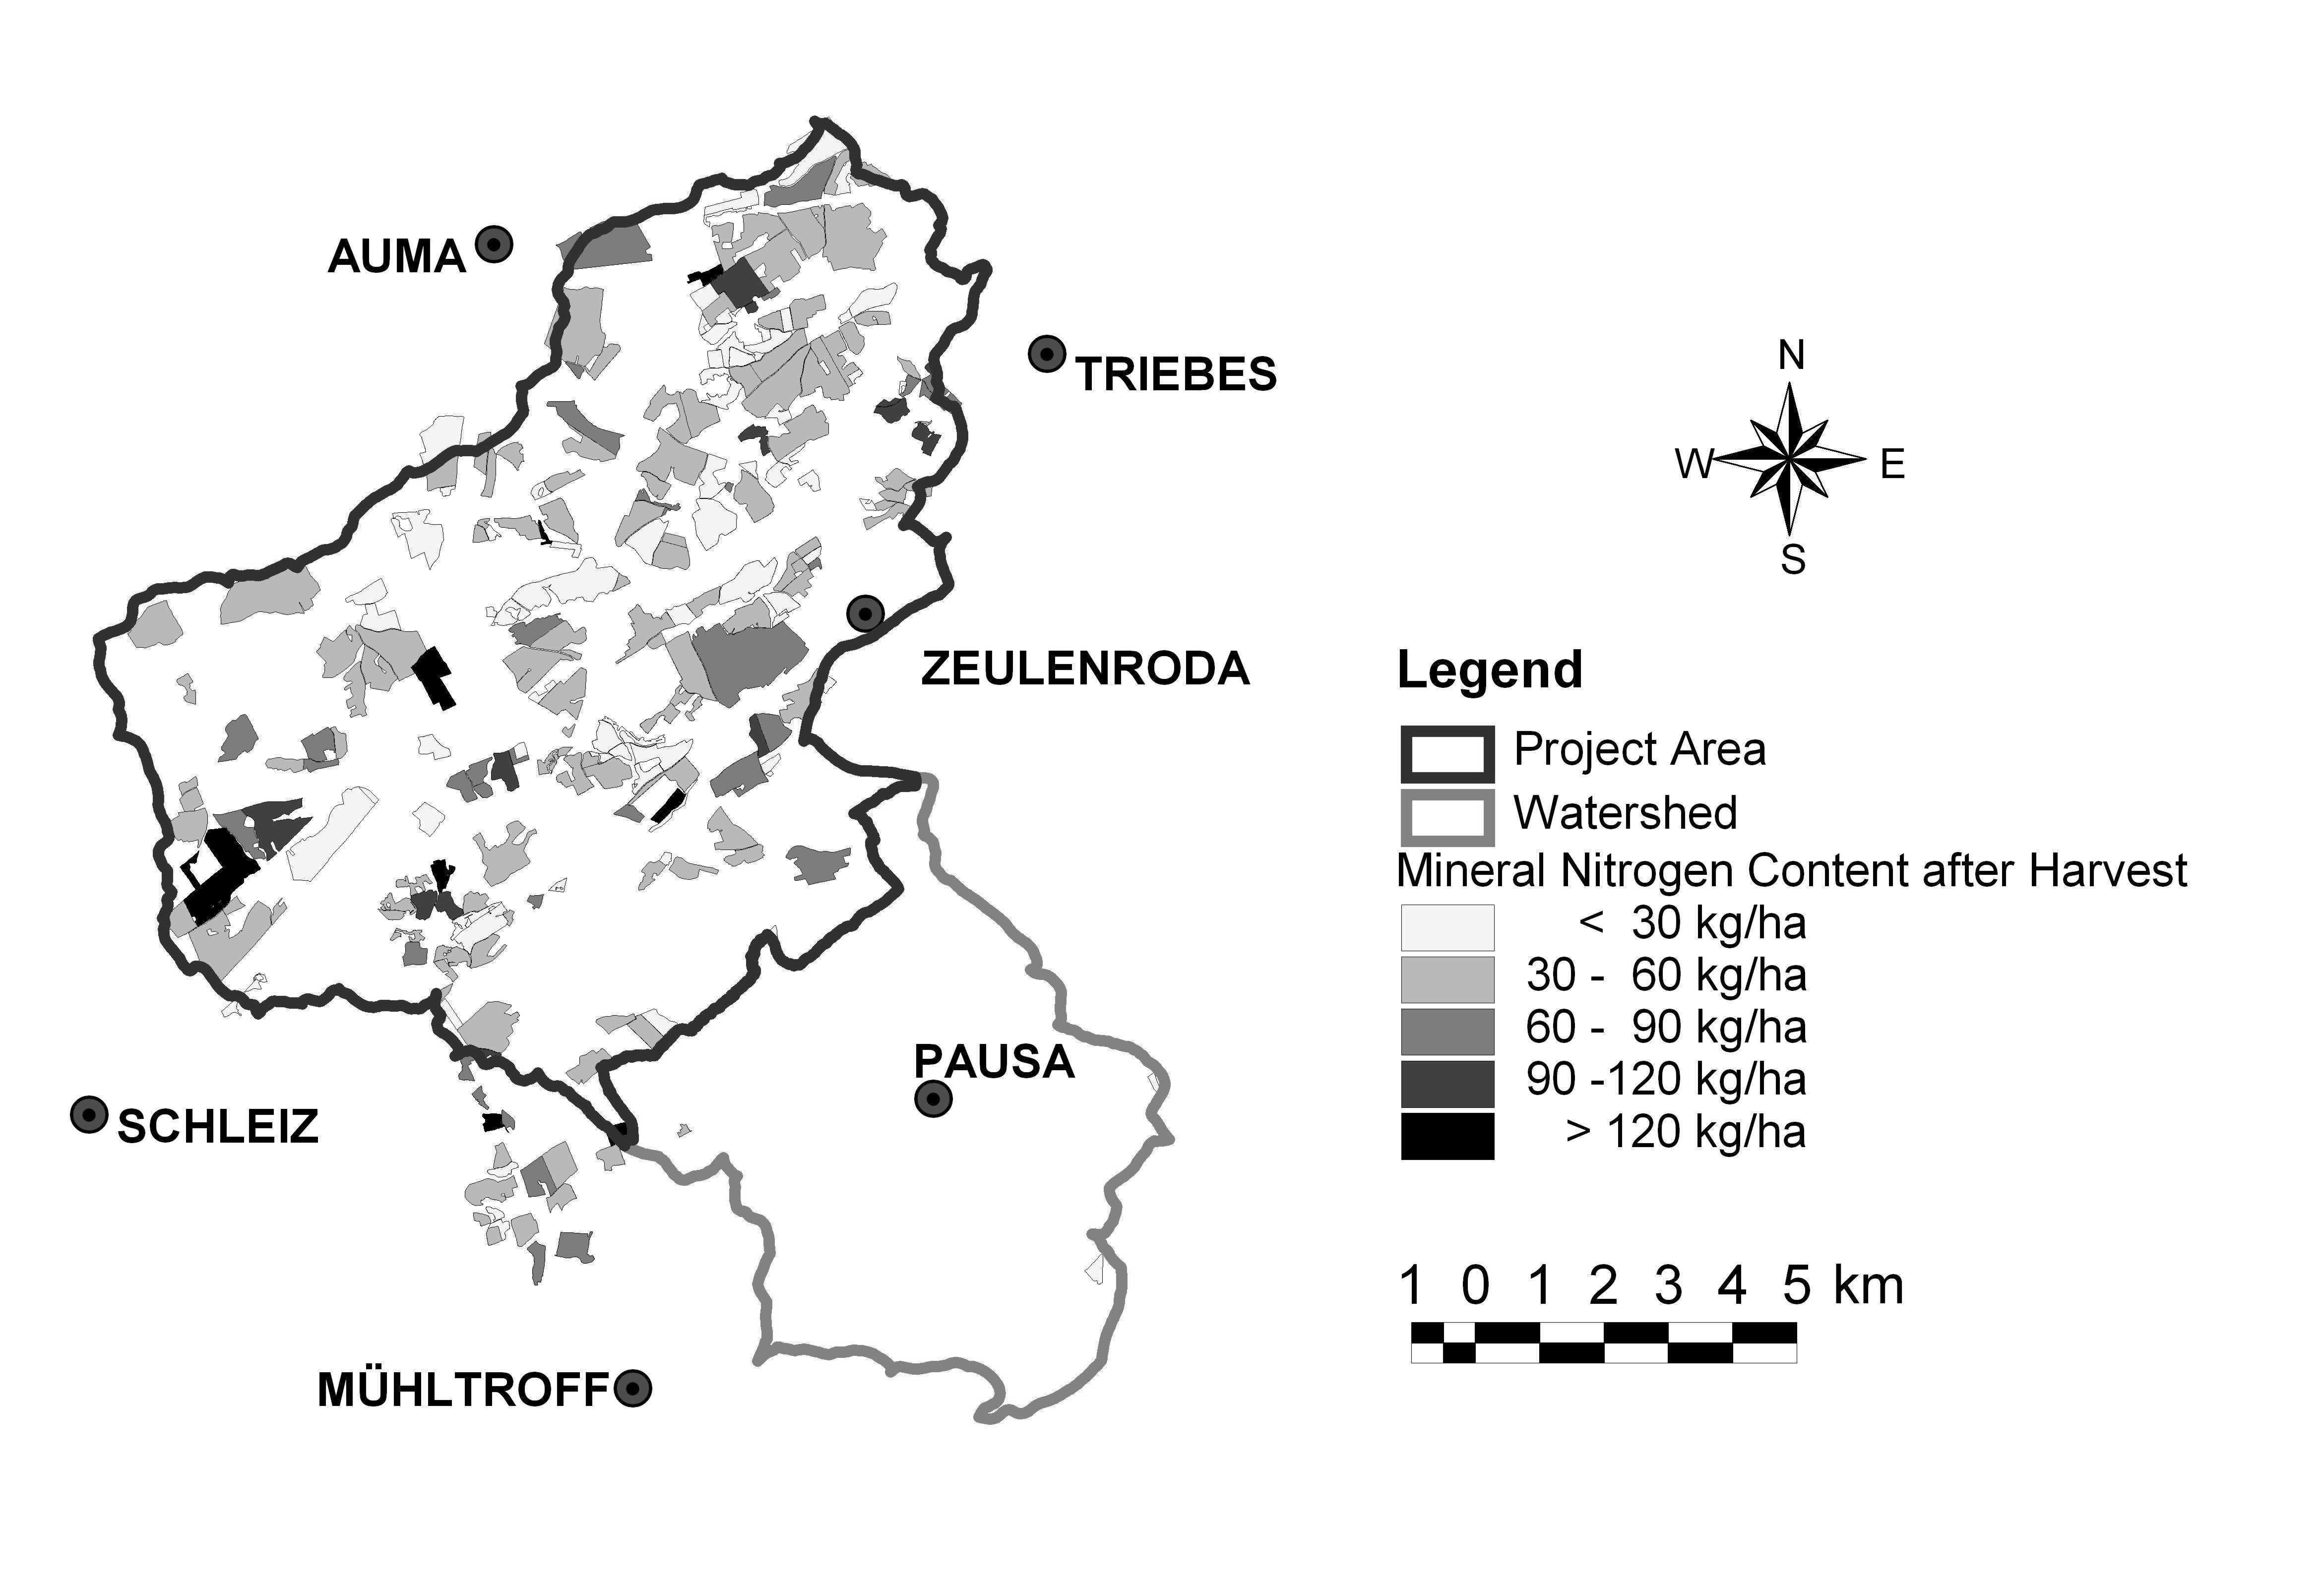
Abbildung 7: Mineral nitrogen content after harvest 2005
Unter Acker lag der mittlere Nmin-Wert nach der Ernte bei 47 kg N/ha, allerdings mit einer Spanne (range) von 13 bis 163 kg N/ha. Abbildung 8 zeigt, dass vor allem bei Silomais, Triticale und Winterweizen erhöhte Rest-Nmin-Gehalte gemessen wurden. Bei diesen Kulturen besteht deutlicher Handlungsbedarf zur Optimierung der N-Düngung.
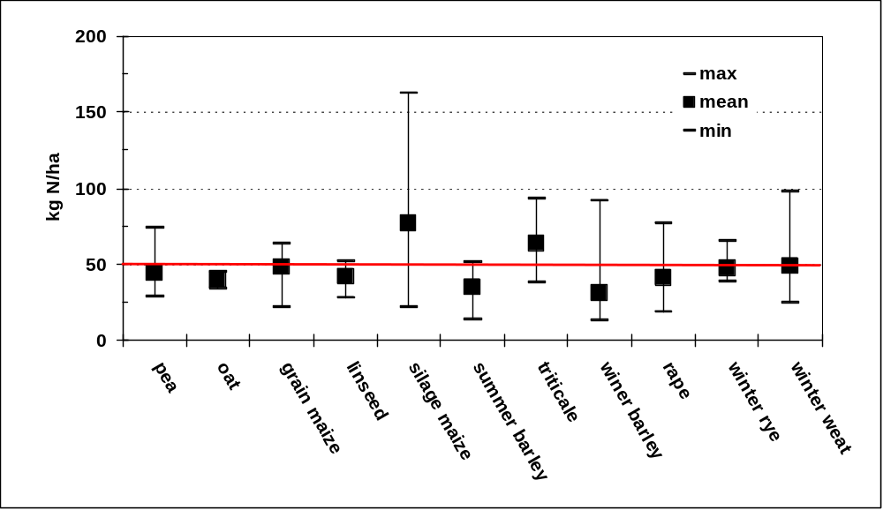
Figure 8: Mittlere Rest-Nmin-Gehalte nach der Ernte der wichtigsten Ackerkulturen
Unter Grünland und Brache lag der Nmin-Wert zum Ende der Vegetationsperiode (Ende Okt.) bei im Mittel 30 kg N/ha, wobei jedoch bei Mähweiden teilweise sehr hohe Nmin-Werte von bis zu 150 kg N/ha bestimmt wurden. Die Ursache hierfür liegt darin, dass ca. 80-90 % der mit dem Futter von den Tieren aufgenommen Nährstoffe durch die Kot und Harnausscheidung auf der Fläche verbleiben. Die Ergebnisse zeigen, dass insbesondere die Weideflächen weiter extensiviert und die Landwirte gezielter bezüglich des Nährstoffmangements auf Weiden beraten werden müssen.
Auf dem Ackerland steigen aufgrund der herbstlichen Bearbeitungsmaßnahmen die nach der Ernte gemessen Nmin-Gehalte bis zum Winter hin noch weiter an. Deshalb wurden auf ausgewählten Flächen zum Ende der Vegetationsperiode nochmals ca. 100 Vor-Winter-Nmin-Gehalte gemessen (analysiert). Die Ergebnisse zeigen, dass die Nmin-Werte der zu beiden Terminen beprobten Flächen von im Mittel 54 kg N/ha nach der Ernte auf ca. 74 kg N/ha vor Winter ansteigen. Bei diesen erhöhten Vor-Winter-(Nmin)-Gehalten besteht eine hohe Wahrscheinlichkeit, dass der Bodenstickstoff während der winterlichen Sickerperiode ausgewaschen und mit dem Interflow ins Oberflächengewässer verlagert (transportiert) wird.
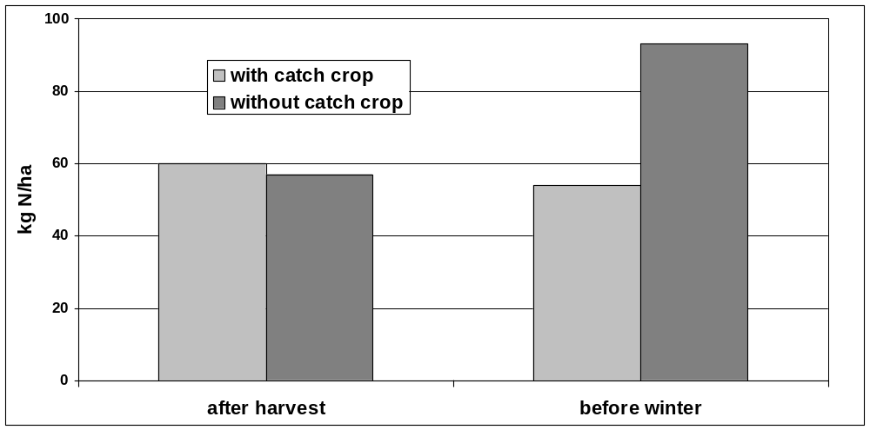
Figure 9: Mean content of mineral nitrogen in soil after harvest and before winter
with and without catch crop
Durch den Anbau von Zwischenfrüchten kann dieser Stickstoff in der pflanzlichen Biomasse gespeichert und damit vor der Auswaschung geschützt werden. Auf den Ackerflächen, bei denen nach der Ernte der Hauptfrucht eine Sommerung folgt, konnten durch den Anbau von Zwischenfrüchten im Mittel ca. 35 kg N/ha in der Biomasse der Zwischenfrüchte gespeichert werden (fig 9). Diese so gespeicherte Stickstoffmenge kann über Winter nicht ausgewaschen werden und steht damit im Frühjahr der Folgekultur zur Verfügung. Die Ergebnisse bestätigen, dass der Anbau von Zwischenfrüchten eine effiziente Maßnahme zur Reduzierung der N-Auswaschungsverluste ist.

Fazit

References
[1] Thüringer Ministerium für Landwirtschaft, Naturschutz und Umwelt (TMLNU), 2005;
http://www.thueringen.de/de/tmlnu/wasser/flussgebiete/modell/content.html
[2] Kralisch, S., Fink, M., Flügel, W.-A., and Beckstein, C. (2003): A neural network approach for the optimization of watershed management. Environmental Modelling and Software, 18(8-9), 815–23.
[3] Reiche, E.-W. (1994), Modelling water and nitrogen dynamics on catchment scale. Ecological Modelling 75/76, 371–384.
Reiche, E.-W. (1996): WASMOD- Ein Modellsystem zur gebietsbezogenen Simulation von Wasser- und Stoffflüssen, Darstellung des aktuellen Entwicklungsstandes.
In Breckling, B. and M. Asshoff (eds.): Modellbildung und Simulation im Projektzentrum Ökosystemforschung, Ökosysteme und ökologische Prozesse im Bereich der Bornhöveder Seenkette. Eco-Sys. Kiel,
http://www.pz-oekosys.uni-kiel.de/ ernst/wasmod/wasmod.html
[4] Flügel, W.-A. (1996): Hydrological response units (HRUs) as modelling entities for hydrological river basin simulation and their methodological potential for modelling complex environmental process systems – Results from the Sieg catchment. Die Erde, 127, 43-62.
[5] Kralisch, S., M. Fink & C. Beckstein (2005): Neural network based sensitivity analysis of natural resource models. In: Proc. International Congress on Modelling and Simulation MODSIM05, Melbourne.

